# Day 1:

#### **Part 1: Creating and Editing Text Files**

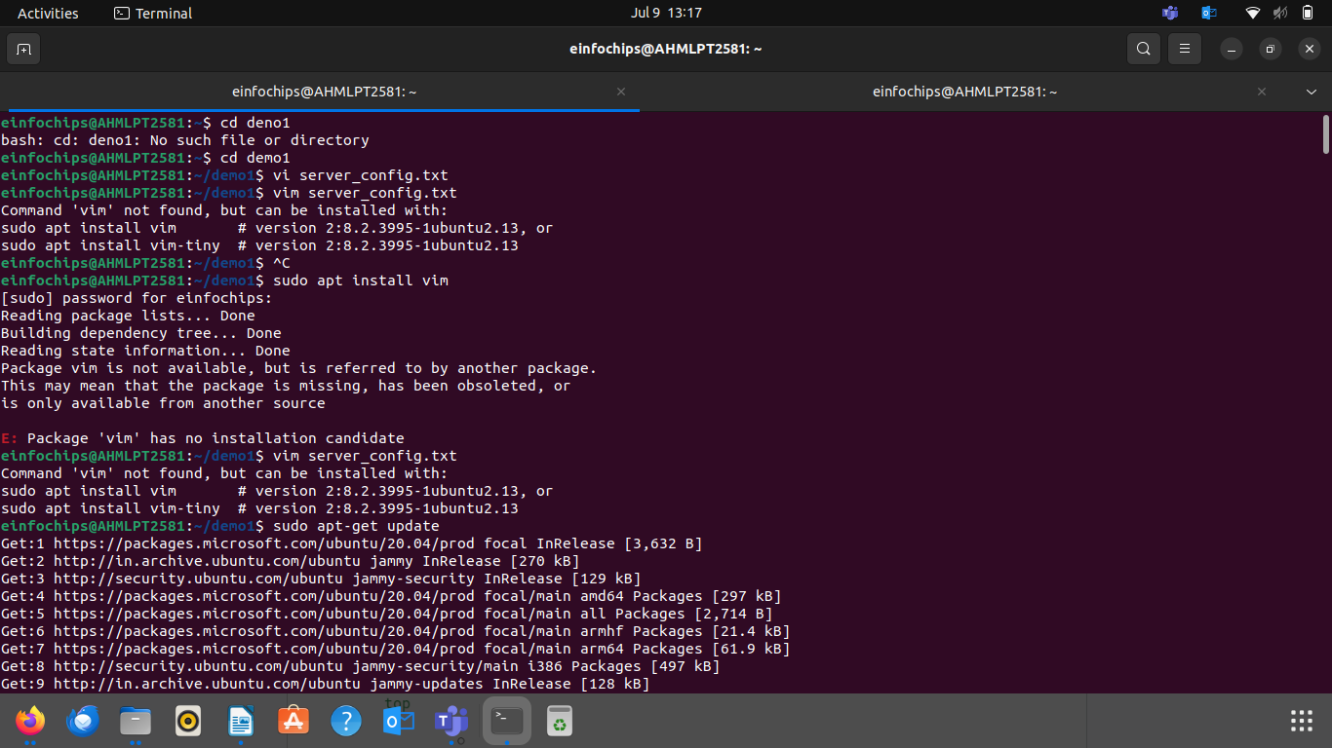

#### **Part 2: User & Group Management**

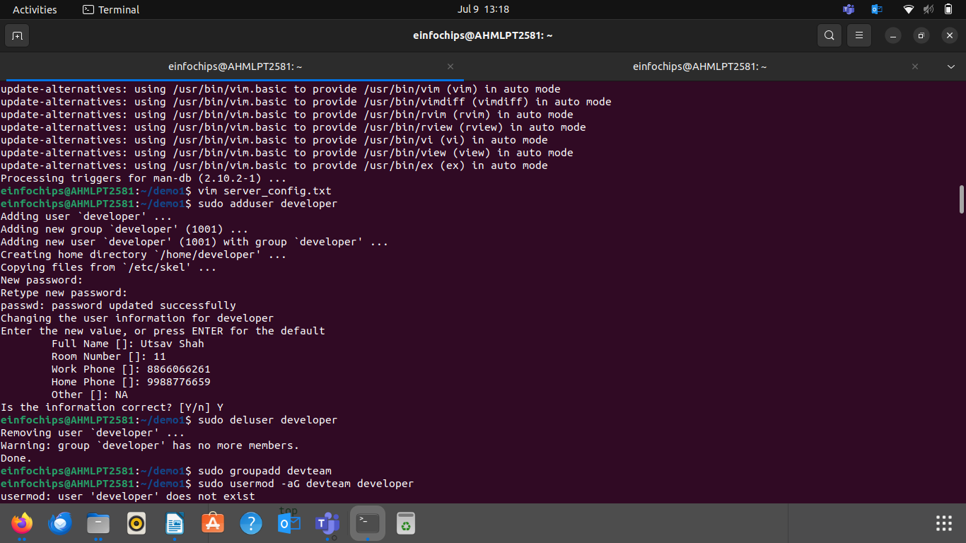

#### **Part 3: File Permissions Management**

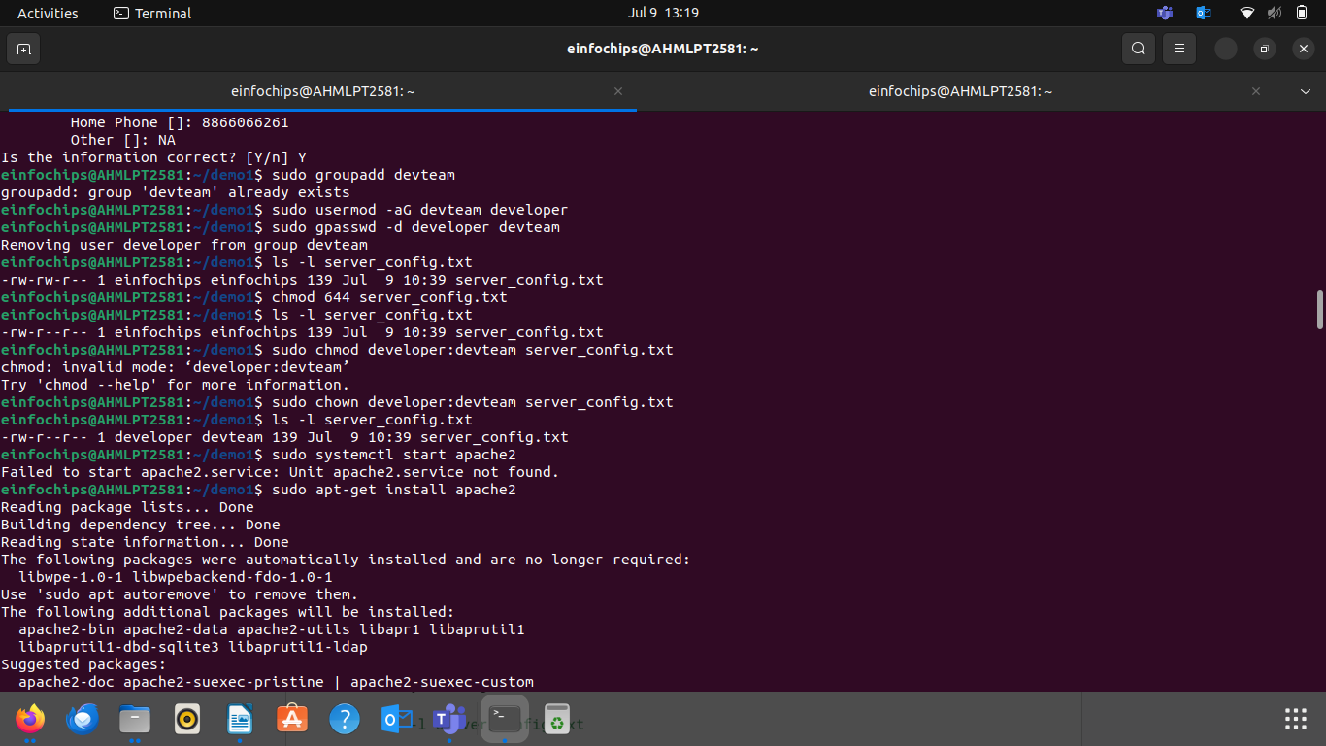

#### **Part 4: Controlling Services and Daemons**

#### 

#### **Part 5: Process Handling**

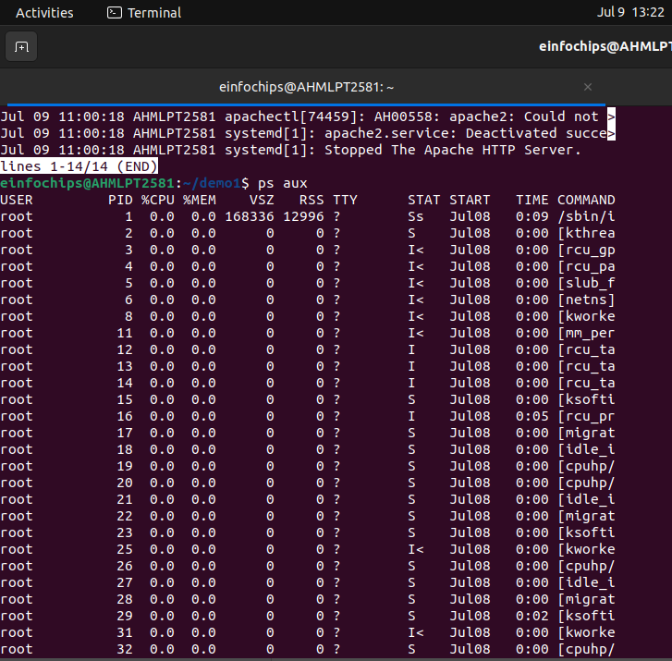

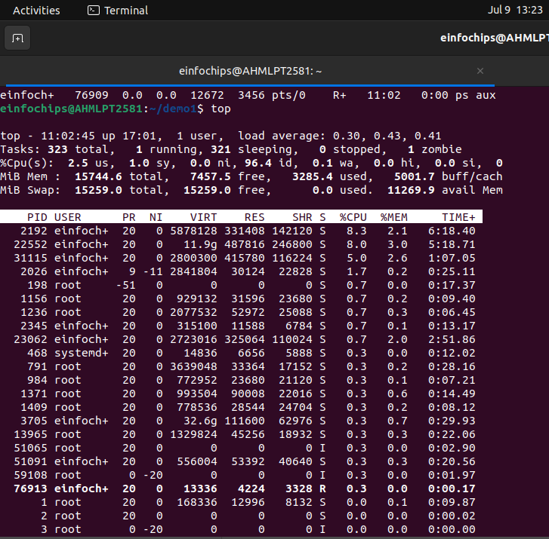

### **Creating and Deploying a Static Website with Apache2**

#### **Preparation**

* Ensure you have access to a Linux environment (e.g., virtual machines, EC2 instances, or local installations) with sudo privileges.

### **Activity Breakdown**

#### **Part 1: Installing Apache2**

**sudo apt-get update**

**sudo apt install apache2**

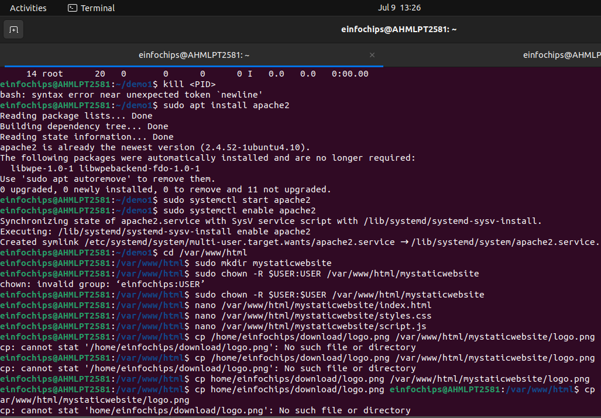

#### **Part 2: Creating the Website**

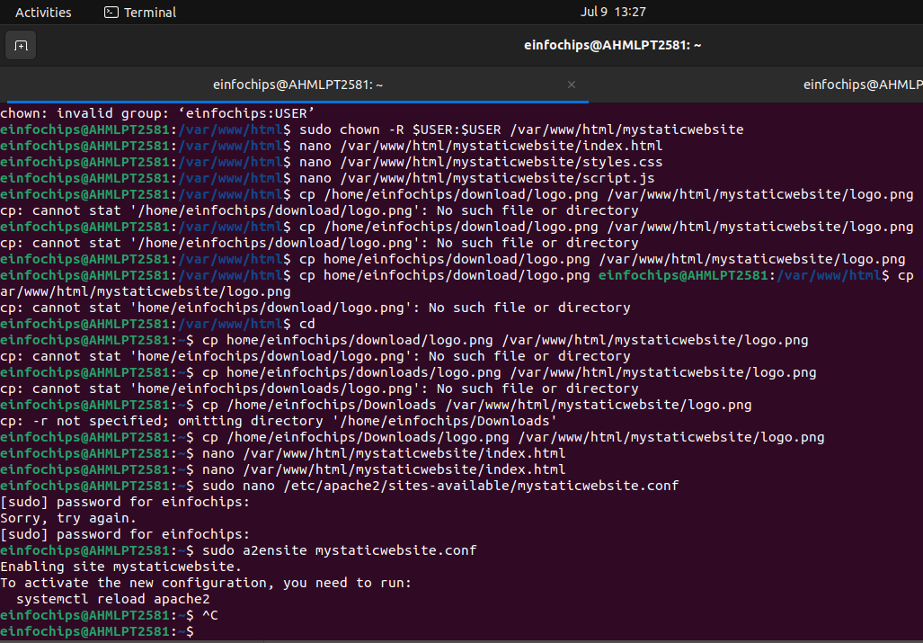

#### **Part 3: Configuring Apache2 to Serve the Website**

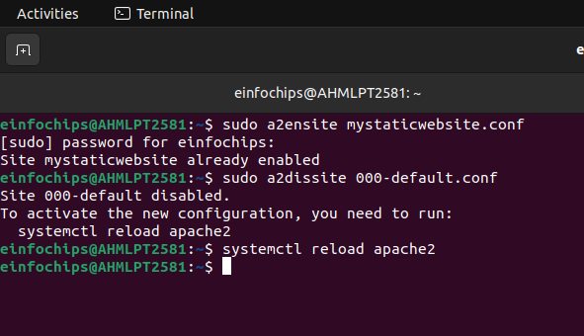**Final Output:**

